**Blockchain - Securing Healthcare Information of patients**

**Ashwin Karthik** (306598726) – [akarthi@calstatela.edu](mailto:akarthi@calstatela.edu)

**Shanmathi ArulMurugan** (306594267) – [sarulmu@calstatela.edu](mailto:sarulmu@calstatela.edu)

**Kaushik Sridharan** (306611492) – [ksridha@calstatela.edu](mailto:ksridha@calstatela.edu)

Department of Information Systems, California State University Los Angeles

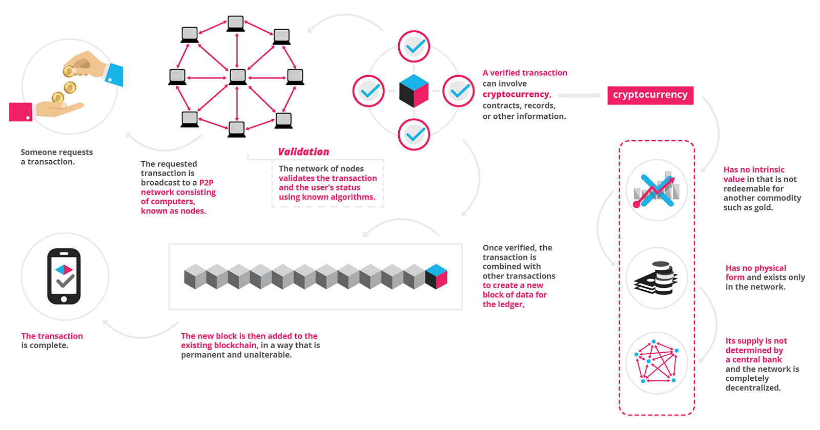

**Abstract:** Blockchain technology has the potential to transform health care, placing the patient at the centre of the health care ecosystem and increasing the security, privacy, and interoperability of health data. This technology could provide a new model for health information exchanges (HIE) by making electronic medical records more efficient, disintermediated, and secure. While it is not a panacea, this new, rapidly evolving field provides fertile ground for experimentation, investment, and proof-of-concept testing.

# Introduction

A blockchain is a continuously growing list of records, called blocks, which are linked and secured using cryptography. Each block typically contains a hash pointer as a link to a previous block, a timestamp and transaction data. By design, blockchains are inherently resistant to modification of the data. A blockchain can serve as "an open, distributed ledger that can record transactions between two parties efficiently and in a verifiable and permanent way.  In a blockchain system, there is no central authority; instead, transaction records are stored and distributed across all network participants. Interactions with the blockchain become known to all participants and require verification by the network before information is added, enabling trust less collaboration between network participants while recording an immutable audit trail of all interactions.

# Work Flow

Every time a transaction is being made between two people, a peer to peer network is requested. Once the P2P network is established, the validation for transaction and the user’s status takes place. The validation is done through people called miners who solve a given problem using unknown algorithms.

Once the validation is verified, the data is being written in a block which is combined with other transactions. This data is now encrypted with a key which will be generated after every new transaction. This new block is added to the existing blockchain in a way that is permanent and unaltered.

# Healthcare in Blockchain

Blockchain technology is a game-changer with the potential to impact not one or two industries, but the complete landscape of how business is done. A blockchain powered health information exchange could unlock the true value of interoperability. Blockchain-based systems have the potential to reduce or eliminate the friction and costs of current intermediaries.

The promise of blockchain has widespread implications for stakeholders in the health care ecosystem. Capitalizing on this technology has the potential to connect fragmented systems to generate insights and to better assess the value of care. In the long term, a nationwide blockchain network for electronic medical records may improve efficiencies and support better health outcomes for patients.

When 200 healthcare executives were surveyed [1], 16 percent expect to have a commercial blockchain solution at scale sometime this year. The key players for blockchain adoption will be regulators, industry groups and market makers.

Better data sharing between healthcare providers means a higher probability of accurate diagnoses, more effective treatments, and the overall increased ability of healthcare organizations to deliver cost-effective care. Blockchain technology can allow various stakeholders in the healthcare value-chain to share access to their networks without compromising data security and integrity, by allowing them to track data provenance as well as any changes made.

# Challenges and Considerations

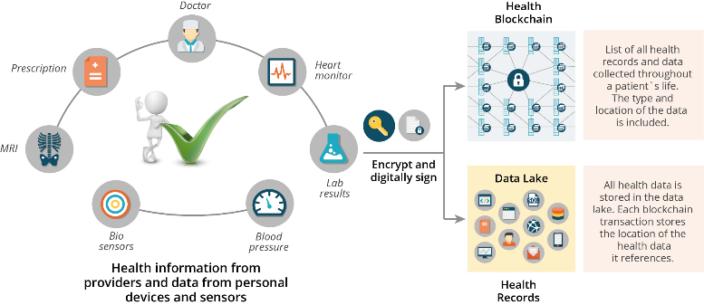Blockchain technology presents numerous opportunities for health care; however, it is not fully matured today nor a panacea that can be immediately applied. Several technical, organizational, and behavioral economics challenges must be addressed before a health care blockchain can be adopted by organizations nationwide.

1. Record Maintenance - “Poor records mean poor defence; no records mean no defence”. Medical records include a variety of documentation of patient's history, clinical findings, diagnostic test results, preoperative care, operation notes, post-operative care, and daily notes of a patient's progress and medications. Maintenance of physical records of over millions of data has always been a problem.
2. Patient Record Confidentiality - Confidentiality in health care refers to the obligation of professionals who have access to patient records or communication to hold that information in confidence.
3. Technology acquisitions, investments, and implementations - Hospital executives have never been frivolous when it comes to investing in technology, but as reimbursements shrink, the need to carefully analyze each purchasing decision has never been more urgent.
4. Implementing Value Based Re-imbursement - Transforming the traditional "siloed" care model into a network care model, both for increased care coordination and the ability to scale effective interventions with the patient population. A significant increase in the need to acquire, aggregate, and analyze data across a healthcare network.

# Applications in Healthcare Sector

# The management of medical data in the form of digital patient records based on blockchain technology can make the patient the “master of his data”. An example of this is MedRec [2], a blockchain-based technology for managing electronic patient records, which is currently under development.

# Examinations such as x-rays and CT images, medication histories and similar can be stored in external databases and be referenced to in the blockchain. This therefore means that the data is available on the computer systems in place at the relevant healthcare provider. An index refers to this data in the blockchain and manages the corresponding access rights.

# The patient can then decide for himself who can access his data and can access it at any time himself. This simplifies considerably the cooperation between the different specialists treating the patient, and the storage and administration of his personal data.

# Technologists and health-care professionals across the globe see blockchain technology to streamline the sharing of medical records in a secure way, protect sensitive data from hackers, and give patients more control over their information.

# Better data sharing between healthcare providers means a higher probability of accurate diagnoses, more effective treatments, and the overall increased ability of healthcare organizations to deliver cost-effective care. Blockchain technology can allow various stakeholders in the healthcare value-chain to share access to their networks without compromising data security and integrity, by allowing them to track data provenance as well as any changes made.

# Every time the doctor tends to you for a medication, a block of data is being written.

# The block of data is encrypted and digitally signed for the authentication.

# It is then stored into the Health Blockchain which contains all the health records and data collected throughout a patient’s life.

# All health data is stored in the data lake.

# QR code validation in healthcare system using blockchain technology

In our project, we have used QR code to scan and maintain each patient data which is not restricted to a hospital.

Usually all the hospital nowadays has their own database of patient records. This documentation is only accessible only to that hospital authority. Whereas the model that we want to build is universally accessible as well as secured.

Following are the steps which defines our project

**Patients View-**

The following steps show the way a patient can access the medical records. These records are read only type i.e, the patient will be able to view their records and will not be able to edit or make any changes.

**Step 1**:

Scan QR code

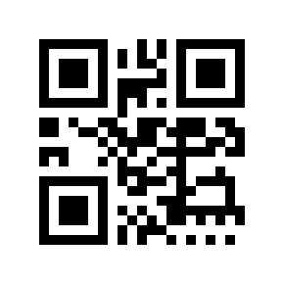

* Every Patient is provided with a unique QR code which is printed on their health card which can be scanned with a qr code scanner and this will lead to the next page. (Login Screen)

NOTE- The details of the patients can be viewed only by scanning the QR code in authorized hospitals. The doctors or the concerned person will be able to view the patients records without the password. Each time the qr code is scanned, the details about who and where the qr code got scanned will be stored automatically in the sheets**.**

* The concept of QR code is implemented in order to secure the confidentiality of the patient’s medical records.

# A screenshot of a cell phone Description generated with very high confidenceLogin screen

* Patients can open the hospital website and click on the patient’s login or scan the QR code which will land to the login page.
* The patient now enters the login credentials to open up their profile
* Now the patient will be able to view all the details like the image given below.
* This log is maintained in order to keep track of the on goings in a particular patient health record. This can be used in future for reference when there is discrepancy.

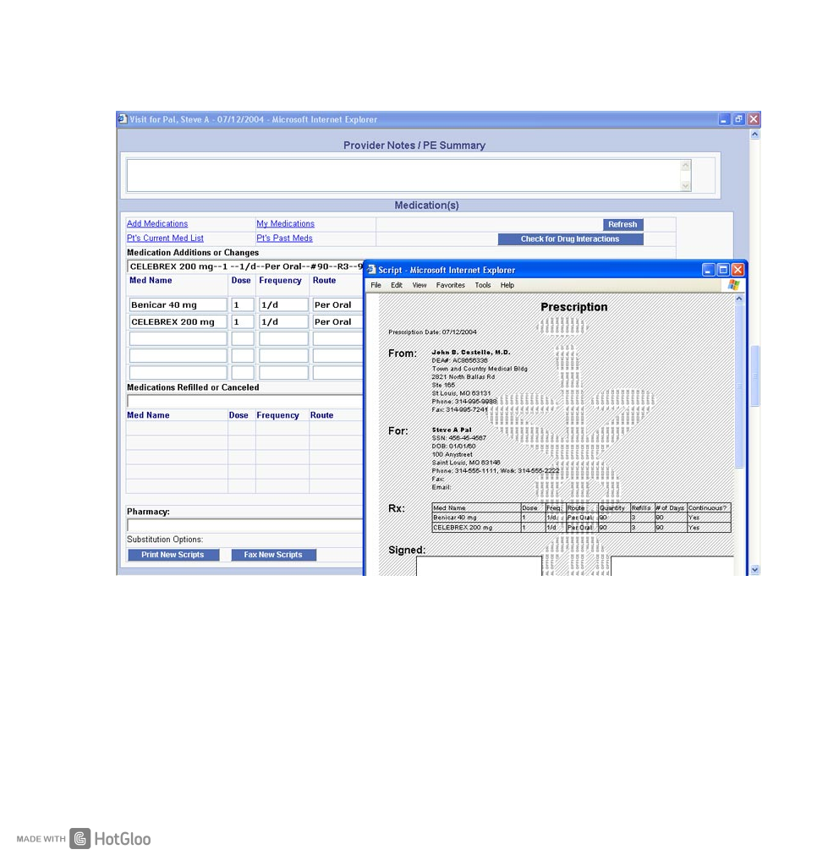**Step 2**:

Once the patient logs into his/her profile, the following will be seen,

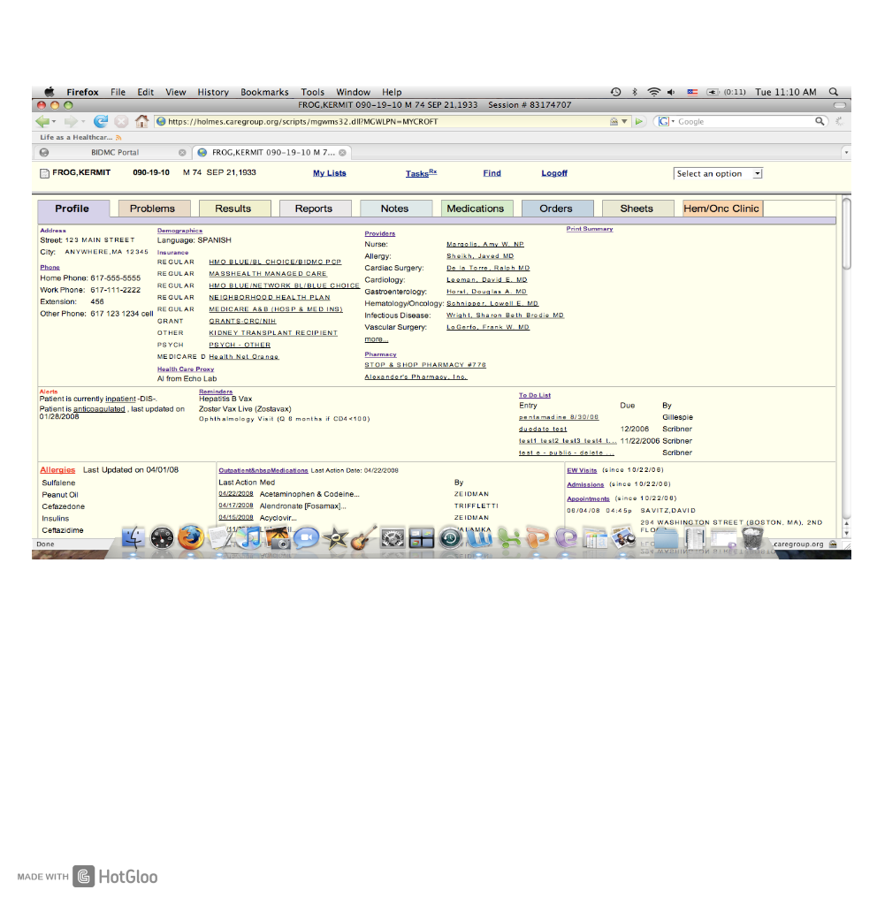**Dash board**

After Logging in, the entire Patient medical history and records are generated for the patients to view. These records include the following tabs,

**Profile** - This tab includes all details about the patient such as name, age, address, phone number, language, Insurance details, to do lists etc.

**Problems**- This tab shows what are the problems that the patient had in the past, problems that the patient current has and also the problems that the patient is likely to have.

**Results** - This tab provides the results of each treatment, such as treatment results, surgery results etc.

**Reports**- This consists of all types of reports that the patient had been advised to take, such as blood report, ECG, MRI etc.

**Notes**- This Tab provides the details of the do’s and don’ts given by the doctor to be followed by the patient.

**Medication**- This tab provides the details about prescribed medicines by the doctor. In this tab we can even check the previous prescribed medicines by the doctors who attended the patient before.

**Orders**- This tab contains the detail about the orders of special medicines and also the orders to be followed.

**Sheets**- This is nothing but the log sheets, ie, it shows the details of the doctors that the patient has been attended by till date. It also shows the details about who has viewed the patient’s details, who has made changes and also from where the profile was viewed in order make the details more secure.

**Hem/Onc**- Hematology-oncology: The diagnosis, treatment and prevention of blood diseases (hematology) and cancer (oncology) and research into them. ... Abbreviated hem-onc.

**The following images shows the details of few tabs mentioned in the dashboard,**

The above images show what is viewed when we click on to the **Notes tab** and medication tab.

**This image shows what is viewed when we click on to the Reports Tab**

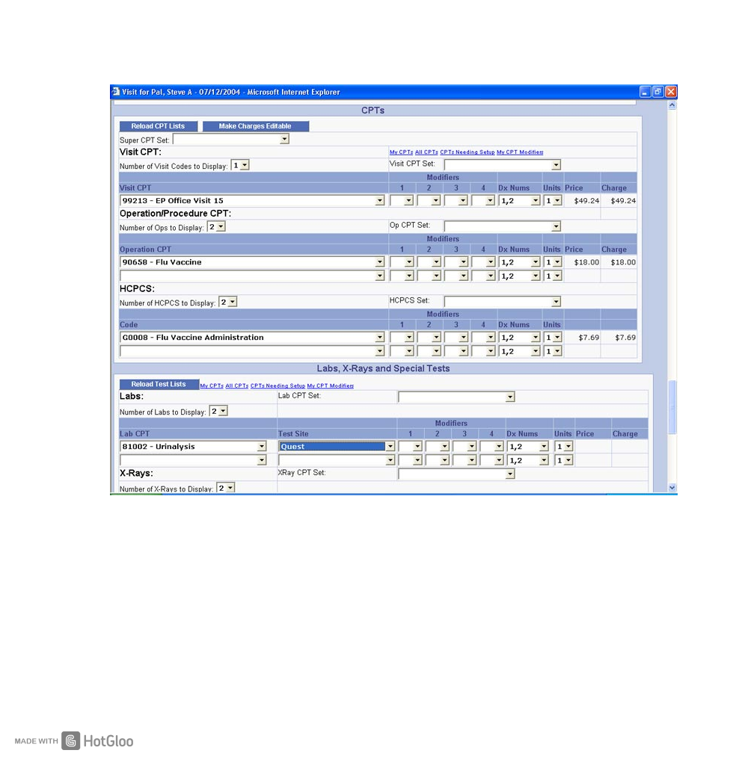

**DOCTOR’S VIEW:**

The following steps show the way a doctor can access the medical records. These records are read and write type ie, the doctor will be able to view the patient’s records and also be able to add on details.

NOTE- The details of the patients other than the profile are not editable, ie the doctor will be able to add on details into the patients records but will not be able to change the previous records.

**STEP 1:**

Scan QR code



* Every Patient is provided with a unique QR code which can be scanned at the Hospitals.
* This encrypted code lets doctor, view patient’s medical history.
* The concept of QR code is implemented in order to secure the confidentiality of the patient’s medical records.

**STEP 2:**

Now the doctor or any person that scans the QR code from authorized zones will be directly able to view the following image,



Now the doctors will be able to view and also add details to the patient record directly without the login screen

Note- The patients record can be viewed by the people in authorized without any password secured login because, lets take an instance where a patient meets with an accident and has been rushed to the hospital, the details should be viewed very quickly, and also the patient might not be in a situation to type in the password.

Now the doctor will be able to add details to the tabs that are in the dashboard like provide prescription like in fig 1.2 and etc

**Limitations**

* Blockchains are de-centralized (No Government official supervision)
* Lack of live data
* Difficult to implement digital data in Medical records
* Unknown outcomes
* Lack of reach among public about blockchain technology

**References**:

[1] <https://www-01.ibm.com/common/ssi/cgi-bin/ssialias?htmlfid=GBE03790USEN&>

[2] <https://hbr.org/2017/03/the-potential-for-blockchain-to-transform-electronic-health-records>

[3] <https://www.ibm.com/blogs/blockchain/2017/10/blockchain-in-healthcare-patient-benefits-and-more/>

[4] <https://www2.deloitte.com/us/en/pages/public-sector/articles/blockchain-opportunities-for-health-care.html>

[5] <https://www.klinik.marketing/allgemein/blockchain-in-healthcare/>

[6] <https://econsultancy.com/blog/7884-the-pros-and-cons-of-qr-codes>

[7] <https://scanova.io/blog/blog/2015/07/14/password-protected-qr-codes/>

[8] <https://www.huffingtonpost.com/entry/blockchain-innovation-in-healthcare-and-life-sciences_us_59c91296e4b0b7022a646c4b>